construction Traffic mANAGEMENT PLAN
Construction of a Residential Development at

182-186 Gertrude Street in North Gosford

Prepared for: Lindfield Group
N233149N (Version 1a)
September 2023



- INTRODUCTION

Motion Traffic Engineers was commissioned by Lindfield Group for the preparation of a (“preliminary”) construction traffic management plan for the demolition, excavation and construction of a Residential development at 182-186 Gertrude Street in North Gosford. Currently the site is three residential houses. The site is within walking distance to Gosford Town Centre. The construction site is located on a narrow service road with no parking permitted.

The purpose of this Construction Traffic Management Plan (“CTMP”) is to minimise the impacts of the demolition and construction works on the public domain, in particular with respect to temporary interruptions to vehicular and pedestrian traffic and ensure that public safety is maintained at all times. A “preliminary” CTMP has been requested by Transport for New South Wales,
The construction hours are 7am to 5pm Monday to Friday and 7am to 1pm on Saturday. No construction activity on Sunday or public holidays.
All construction activity will be contained within the construction site except for the following occurrences:
- A work zone (or temporary road occupancy) is required when the building line is in place on the service road that runs off Gertrude Street
  - Trucks will be able to enter and leave in a forward manner during the demolition and excavation stage and do not need a work zone
  - The same work zone will be used for kerb, gutter and minor crossover construction on the site frontage
- Construction driveways on Gertrude Street

Truck swept paths have been undertaken to show a truck can enter and leave in a forward manner and presented later in the report. The truck swept paths for the demolition and excavation stage show where the construction driveways are. The truck swept paths are discussed later in the report.

The following traffic guidance schemes have been prepared:
- Managing traffic movements on the service road when here there is a truck on the work zone

The following conditions will be adhered to:

- All construction activities, including loading and unloading of materials and equipment will be carried out from within the work site boundary.

A works permit will be sort from the council for use of the road reserve as required for the following activities:

- Loading and Unloading from the kerb side
- Operation of concrete pump from the kerb side
- Any other construction activities that require the occupation of the road way or footpath/nature strip.
- No works are to be carried out on public land or the road reserve without prior consent from the relevant Authorities
We understand that a crane will be used. A separate application for crane and installation will be made when the actual time will be needed (assuming Development Application approval)

Figure 1 shows the location of the site and the surrounding road network and traffic direction on an aerial photograph. The following Figure show photograph of the site and the service road.

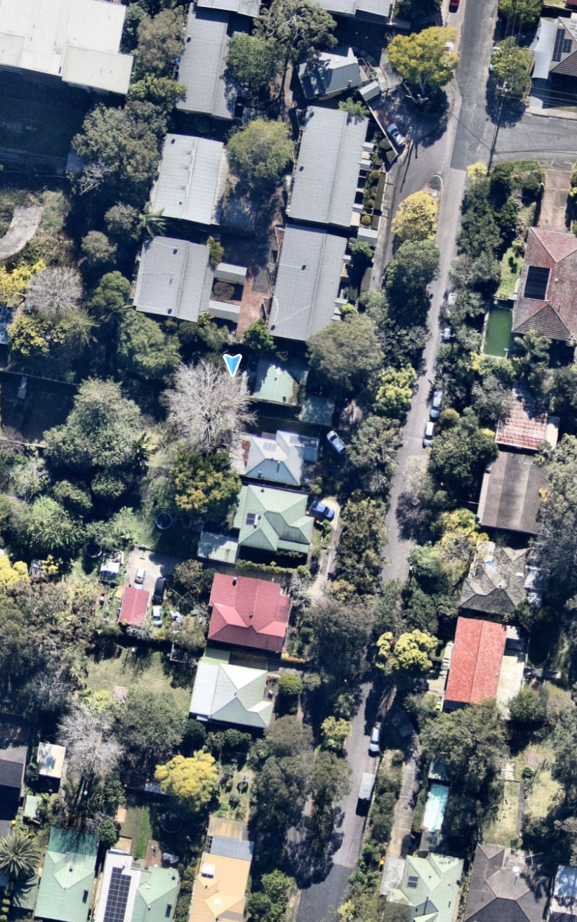
site
Figure 1: Location of the construction site on Aerial

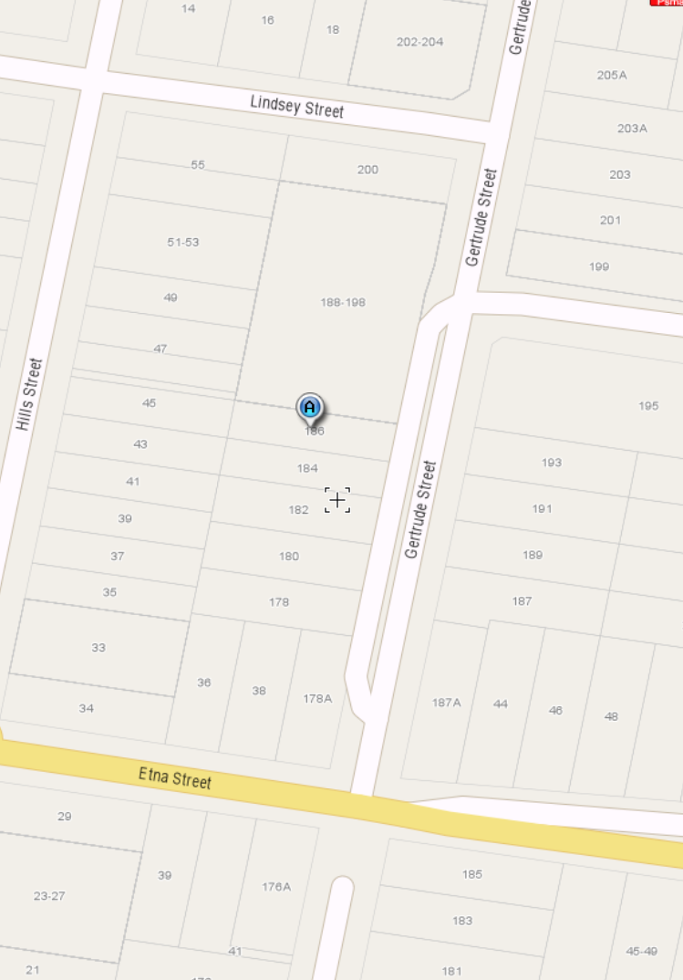
site
Figure 1: Location of the construction site on Street Map Perspective

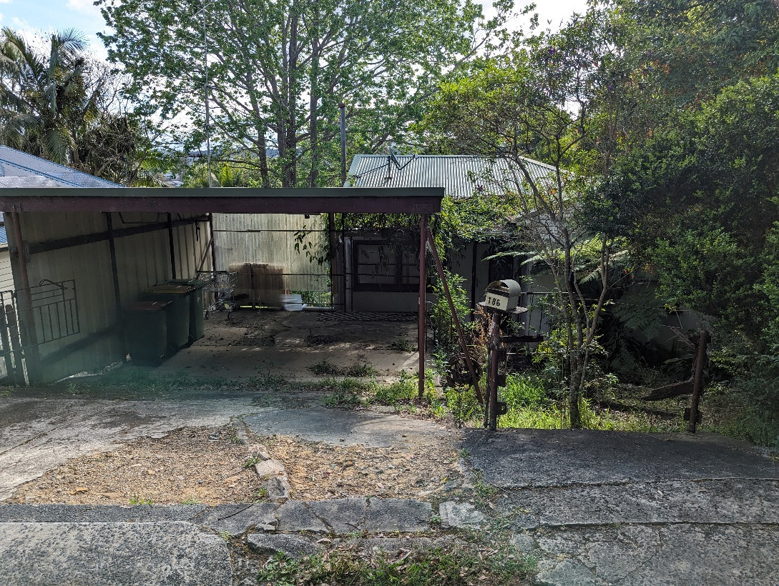
Figure 2A: Photograph of 186 Gertrude Street
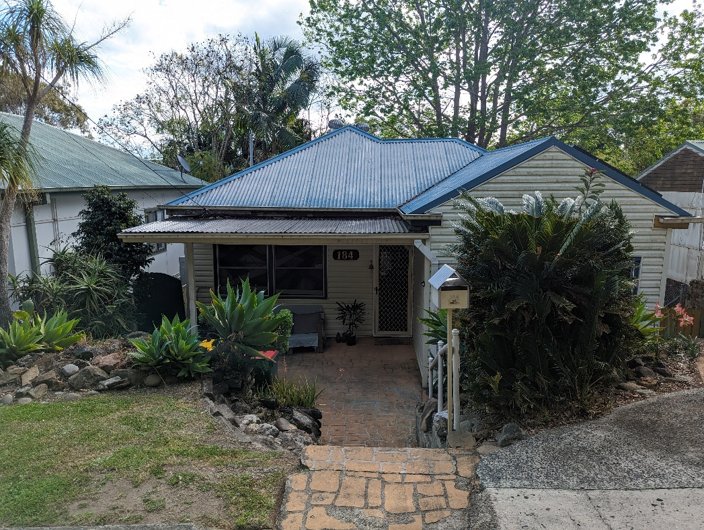

Figure 2B: Photograph of 184 Gertrude Street

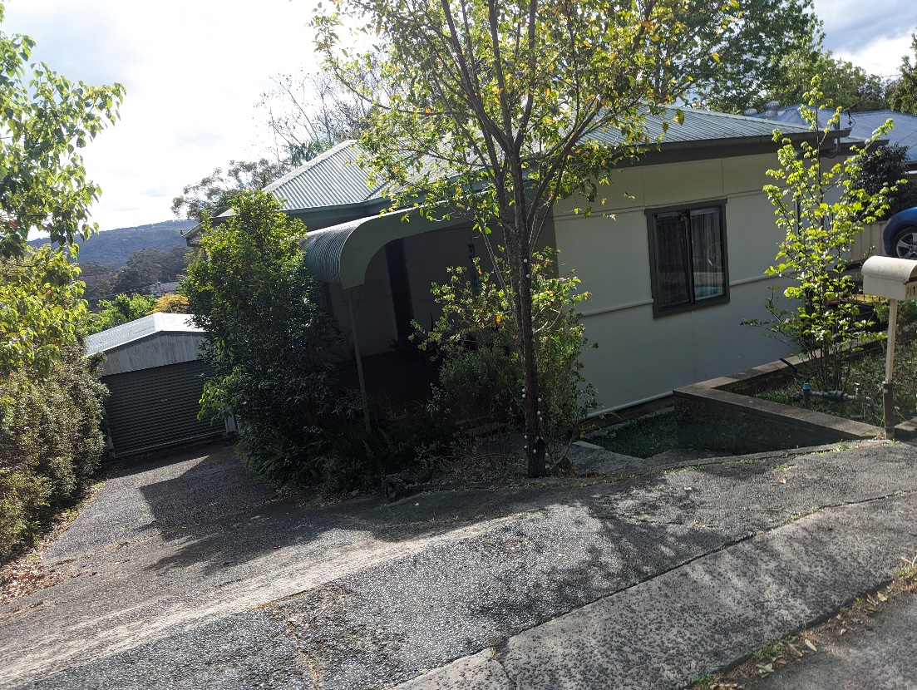
Figure 2C: Photograph of 182 Gertrude Street
Figure 3: General Location of the Work Zone

- EXISTING SITE CONDITIONS
  - LOCATION AND LAND USE:
The construction site is located within walking distance to Gosford Train station and is at the periphery to North Gosford Town Centre. The immediate surroundings of the site are residential houses with an apartment block at the northern end of the service lane. There are no formal pedestrian footpaths on the service lane. There is no on-street parking with sign stating this at the service lane entrance.
  - EXISTING TRAFFIC VOLUME & MANAGEMENT PLAN
The construction site is location on a one-service that runs from south to north. The service lane runs off Gertrude Street. The existing vehicle traffic lanes are less than 20 an hour in any give hour. The vehicle traffic volumes are low on the service lane. Pedestrian traffic volumes are low as well.

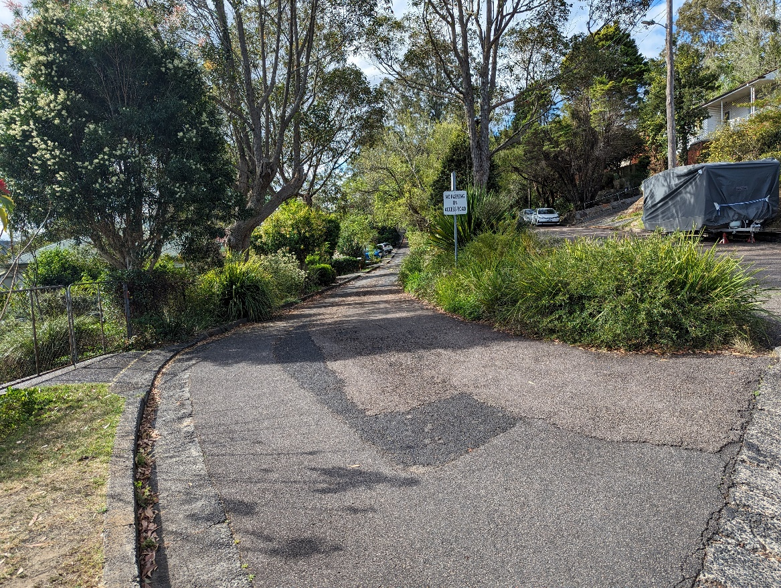
Figure 4: Photograph of the service Lane

Traffic controllers will manage vehicles and pedestrians throughout the demolition, excavation and general construction stage.

- PARKING IMPACTS

The construction activity does not reduce on-street parking on the service lane or on Gertrude Street.
All car parking offsite by the construction workers will be in legal parking areas and not on the verges or footpaths.
Where possible, construction workers will park within the on-site basement car park.

- TRAFFIC IMPACTS

The work zone on the service lane will restrict through movement on the one-way service lane. Traffic controllers will manage residential access/egress for their on-site parking. The one sections that are bifurcated by the work zone will be two way with traffic controllers’ managing the traffic movements.

The traffic controllers will guide all vehicle movements on the service lane to minimise the inconvenience and traffic to the residents and visitors.

All resident on the service lane will be informed of the changes through a regular letter drop as well as a verbal conversation with traffic controller’.

The impact on local traffic of construction traffic on the adjacent roads (such as Ormond Stret) will be kept to a minimum. The following will be implemented to achieve this:
- The construction trucks travelling to the site will be using major roads that permit trucks and through traffic such as M1, A49, and Pacific Highway (Mann Street)
- The timing of the truck arrivals and departures will be outside of the commuter peak periods
- Truck movements will only occur during permitted construction periods on a weekday and Saturday only
- The cars of the construction workers will park either on site or on the public parking areas away from the site. Where possible, some will use public transport to travel to and from the site and takes into accounts Gosford Train Station is about 350 meters away (approximately)
- Vehicle access to neighbouring properties will be retained.

The entire frontage of the property will be fenced off with temporary fencing for security and safety in accordance with WorkCover requirements.
All statutory safety and warning signs to be erected and maintained at all times.
No machinery or material will be stored on the footpath or verges or on public areas.
Pedestrians will be advised to watch their step and on days of truck movements across the construction site driveway.

- SITE CONDITIONS

The site is provided with adequate controls to ensure the safety and security of the construction site and to constrain environmental impacts. The following presents details of the safety, security and environmental controls provided on site.

Fencing

- A 1.8 metre fencing surrounds the site to prevent unauthorized personnel from accessing the site from entering the site. It provides a single entry point for authorised personal. Fencing also provides security and safety to the site and ensures that potential safety hazards are constrained to the site area.

Erosion and Sediment Control Fence

- An erosion and sediment control fence surrounds the site to prevent or minimise erosion while constraining loose soil to the site. The control fences will also aid in minimalizing the environmental impact on the surrounding flora and fauna.

Wooden Mats

- Wooden mats are placed at the site entrance as additional support for heavy vehicles. The mats serve to spread out the weight of the heavy vehicles whilst also aiding in stability on loose unstable ground conditions.

Cattle Grid

- A cattle grid is placed within the site boundary at the site entrance to shake loose dirt and large materials such as, pebbles and rocks, off a vehicle as it drives over the cattle grid. Vehicles exiting the site are simultaneously washed off to capture air born soil particles discharged from the vehicle as a result of driving over the cattle grid.

Silt Arrestors

- Silt arrestors are placed along the gutter adjacent to the site entrance. These catch loose silts and dirt washed of the cattle grid and out of the site entrance.

Bins

- Bins are located adjacent to the site office which allows for easy access by the vehicles on site.
- The bins are used to centralise and contain site waste material such as pallet wrap and broken/damaged materials to reduce site hazards

Emergency Evacuation point

- The emergency evacuation point is located at the front of the site office.

Site Office

- The site office is located adjacent to the entrance and next to the bins. The location allows for convenient access and view of the construction site. First aid is located in the site office. The site office allows for visitors to engage in a site induction before having to travel to far through the site.

  - PUBLIC TRANSPORT SERVICES
There will be no interruption to bus services or bus stops.
  - EMERGENCY VEHICLE ACCESS
Access for ambulance or fire fighting vehicles will not be impeded.

- TRUCK MOVEMENTS

The details and frequency of the truck movements and the corresponding Traffic guidance scheme are as follows in the following Table 1 and the appropriate traffic guidance scheme in use and the frequency. The truck usage is overall low and most arrivals are pre-planned to within a time frame of 20 minutes.

Phase | Duration | Workers Onsite | Largest Vehicle | Loading / Unloading Location | Truck Movements | TGSs Used & Frequency
Demolition | 6 weeks | 5 | 12.5 metre heavy rigid truck | Onsite | 4/day | TGS 1: Work Zone on the service lane (4 times a day)
Excavation | 10 weeks | 4 | 15 metre “truck and “ dog” | Onsite | 10/day | TGS 1: Work Zone on the service lane (10 times a day)
Construction | 52 weeks | 20 | 10 m rigid truck | Work zone | 4/ day | TGS 1: Work Zone on the service lane (4 times a day)
Kerb, gutter and crossover construction | 1 day | 5 | 10 m rigid truck | Work zone | 4/ day | TGS 1: Work Zone on the service lane (all day)

Table 1: Summary of Truck Usage by Construction Phase and Traffic Guidance Scheme Used

The above staging plan is indicative and subject to normal and unforeseen delays that occur on a construction site.
The number of truck movements on a daily basis is relatively low over a working day. Truck movements will only occur during permitted construction periods Monday to Saturday. Whenever possible, the timing of truck arrivals and departures will be planned to avoid peak commuter periods.
The inbound truck routes are as follows to the work zone on Gertrude Street :
- North: Truck drivers coming from the North will travel on the M1, Pacific Highway, Mann Street, Etna Street, Gertrude Street and service lane
- South: Drivers from the South will travel on M1, A39, Pacific Highway, Donnison Street, henry Park Drive, Etna Street Gertrude Street and service lane
- East: Drivers from the East will travel on A39, Dane Drive, Pacific Highway, Donnison Street, henry Park Drive, Etna Street Gertrude Street and service lane
- West: Truck drivers coming from the West will travel on M1, A39, Pacific Highway, Donnison Street, henry Park Drive, Etna Street Gertrude Street and service lane
The outbound movement is to travel towards Lindsey Street, left into Lindsey Street, and then left or right into Pacific Highway (Mann Street) depending upon destination at the priority intersection of Pacific Highway (Mann Street) with Lindsey Street.

  - Truck Swept Paths
Trucks swept paths have been undertaken to show 15 metre “truck and dog” and a 12.5 metre long heavy rigid truck entering and leaving the site in a forward manner.
The truck swept paths for the demolition and excavation stage show where the construction driveways are.
The truck swept paths are presented in Appendix B.
- OTHER ITEMS

  - COMMUNICATION WITH NEARBY TENANTS
Site manager shall give nearby resident’s reasonable notice of any planned Works that may adversely affect traffic at least 48 hours prior to construction work commencing.

  - TRAFFIC MANAGEMENT PLAN CHECKLIST
This section responds to the checklist in the document titled “Procedures for Use in the Preparation of a Traffic Management Plan (TMP)” prepared by the NSW RTA (now RMS) with the document dated 2001.

 | Traffic Management Plan Issues | Response
A | Detailed plan of proposed measures | Yes – see Report.
B | Identification and assessment of impacts of proposed measures | Yes – see Report.
C | Measures to ameliorate the impact of the Works | Yes – alternative vehicle routes available.
D | Assessment of impact on Public Transport | No impact on Public Transport.
E | Assessment of impact on Emergency Vehicles | Emergency vehicles have alternative access routes.
F | Assessment of impact on traffic movements in adjoining areas | Nil. Impacts are local.
G | Consideration of pedestrian access issues. | Yes. Numerous pedestrian pathways available.
H | Public consultation process. | Yes. Notices to neighbours as required.

Table 2: Traffic Management Checklist

- TRAFFIC GUIDANCE SCHEMES

This section discusses the preparation of traffic guidance scheme managing both pedestrians and trucks entering and leaving the construction site and the occupancy of the kerbside lane.
- Managing traffic movements on the service road when there is a truck on the work zone

The preparation of the Traffic guidance schemes has been in accordance with Australian Standards AS1742.3 and the RTA Traffic Control at Work Sites (now the TfNSW).

Benny Chen is licensed and registered by the TfNSW to design and inspect traffic guidance schemes.

Table 1 presents the use of Traffic guidance schemes according to each construction phase and the expected frequency of use per day.

The Traffic guidance scheme is presented in a clear manner to allow for the plan to be implemented by the works supervisor. The placement of the signs is from a key identifier. The works supervisor will need to be TfNSW accredited. The Traffic guidance schemes are presented in Appendix B.

Where there are two controllers require, radios will be used to communicate the implementation of the traffic guidance scheme between controllers.

All barriers used in traffic control will need to be compliant with Australian Standards.

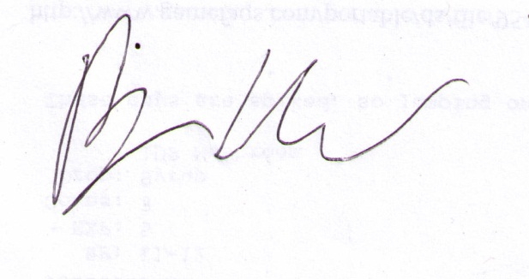

Benny Chen
Principal
(NER)

Appendix A
traffic guidance schemes

Appendix B
tRuck swept paths

